<https://codeburst.io/hack-the-box-how-to-get-invite-code-56e369fc8dae>

1. First, visit the [Hack the Box site](https://www.hackthebox.eu/) and read along its FAQs and other useful stuff written there.
2. You will be told to go to <https://www.hackthebox.eu/invite> to join HTB.
3. When you go to that page, you will see a text box asking you for an*invite code*.
4. Right click on the page, and open inspect element. Alternatively, press Ctrl+Shift+I to open the Chrome Developers Tools.
5. Go through the elements tab and you will find a script with source (src) as: /js/inviteapi.min.js

Image for post

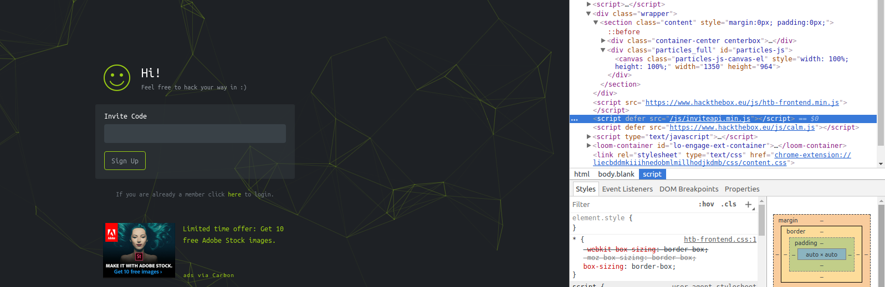

See the script src: /js/inviteapi.min.js

6. So now, go to <https://www.hackthebox.eu/js/inviteapi.min.js> . You will see a JS file like this.

Image for post



See the makeInviteCode which is highlighted

7. makeInviteCode looks interesting. So let’s go back to <https://www.hackthebox.eu/invite> and try to find its contents.

8. Goto console tab in Chrome Developer Tools, and type makeInviteCode() and press ENTER. You will get a 200 Success status and data as shown below.

Image for post

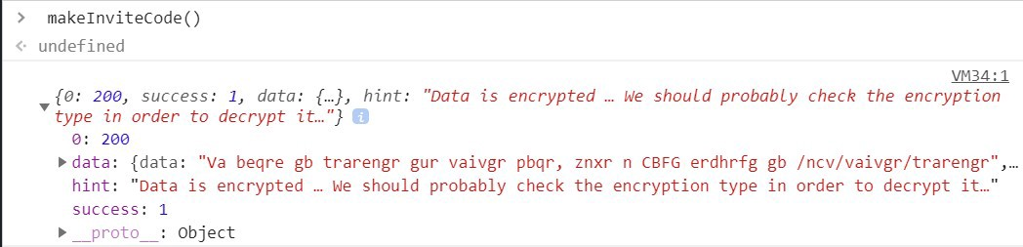

See the hint and data

9. When you click the small arrow alongside *data,*you will see that the text is encrypted and the encoding type is **ROT13**.

Image for post

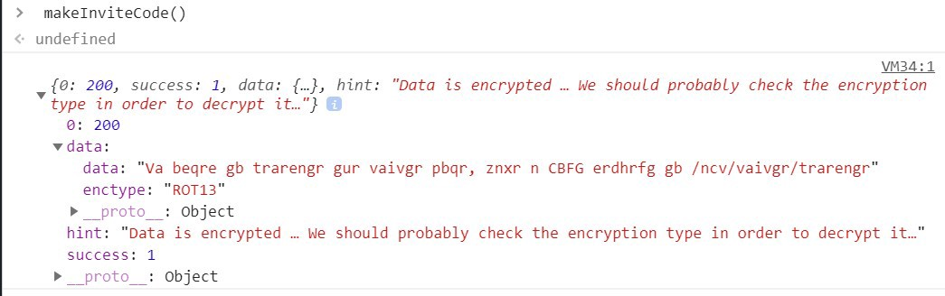

ROT13 Encoding Type

10.Let’s decode that message! Copy the contents of data. And open decoder:  
<https://soumya.dev/decode>

11. Select**type: ROT13**, paste the copied data onto the **Encoded Text box** and click **Decode**. You will get something like below.

Image for post

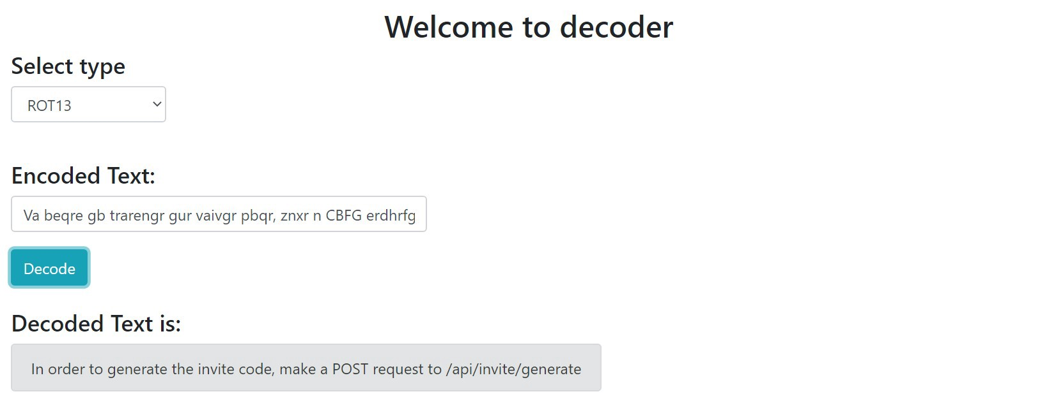

12. So, as we can see in Decoded Text, in order to generate an invite code, we need to make a POST request to “[https://www.hackthebox.eu](https://www.hackthebox.eu/)/api/invite/generate”.

13. Fire up your terminal/ command-prompt. And make a POST request by typing:

***curl -XPOST***[***https://www.hackthebox.eu/api/invite/generate***](https://www.hackthebox.eu/api/invite/generate)

14. You will get a success message as:

{“success”:1,”data”:{“code”: “**somerandomcharacters12345**”, “format”: “**encoded**”}, “0”:200}

15. As you saw, we code a code. But this is not our invite code as it says *format:encoded.*

16. Lets’s try decoding it, by again using decoder: <https://soumya.dev/decode>.

17. But this time, select **type** as **Base64.**Paste the code you got as the response of the POST request into the Encoded Text box and press Decode. *Voila! You get your invite code.*

Image for post

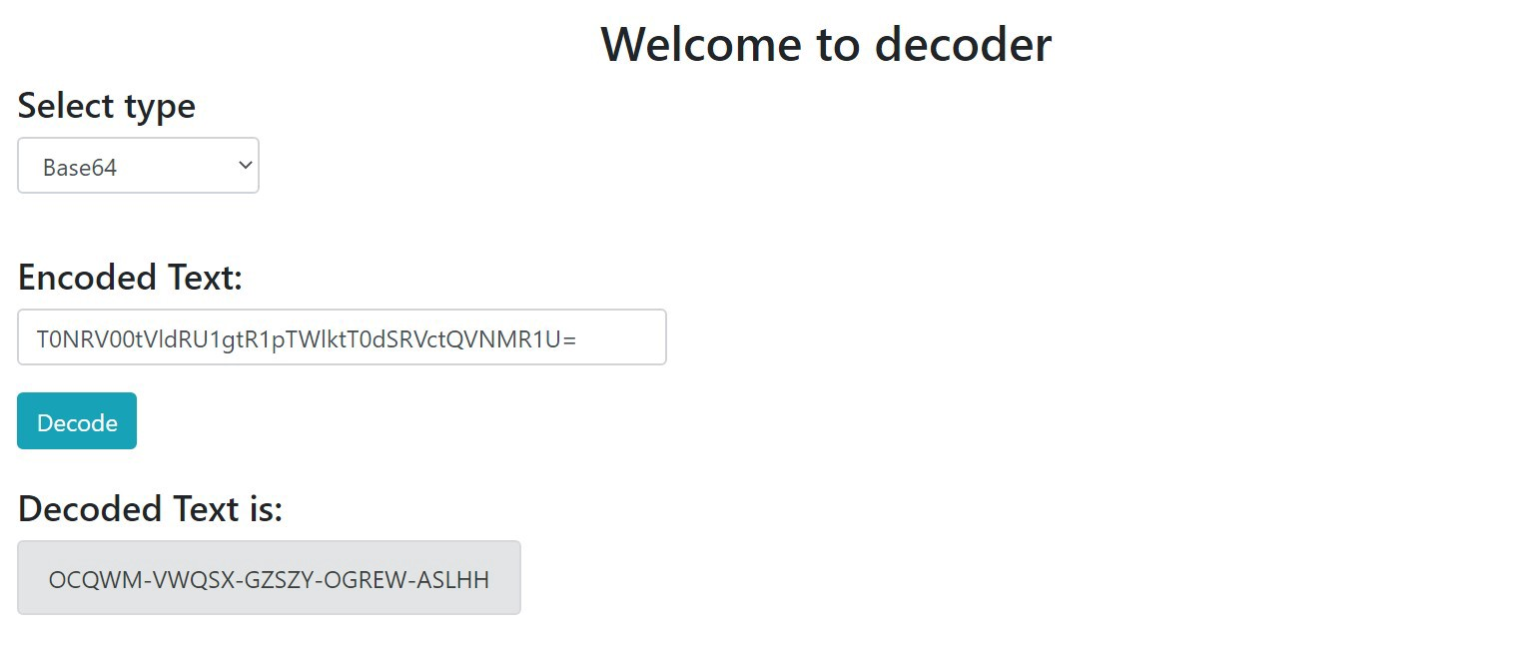

You get your invite code (Don’t try using this invite code as it won’t work for you)

18. Now, finally go to <https://www.hackthebox.eu/invite> and paste the Invite Code you got in the textbox asking for the same.

19. You’re in! You can sign up on the site now and become a member.